**AI-POWERED NUTRITION ANALYZER FOR FITNESS ENTHUSIASTS**

ABSTRACT :

AI powered nutrition analyzer enthusiast proposes an intelligent agent for setting up diet plans based on the inputs provided by the user. The system creates a meal plan in accordance with person’s lifestyle and health requirements. The online artificial dietician is a system having artificial intelligence about human diets. Due to the modern lifestyle, carefree attitude and being materialistic, people are taking their health and diet otherwise. These days people tend to suffer from numerous health disorders and fitness problems majorly due to an unbalanced diet.

In the present scenario, there is a trade-off between health, wealth and time. Many a time, they are ignorant about the right nutrient value for a healthy being. Therefore, to facilitate them with a proper diet chart along with light exercises according to their lifestyle and cope up with their busy schedule, a need for software emerges that can provide diet consultancies to the people at their preferred time and mobile phones without having to visit a dietician.

INTRODUCTION :

The pace with which the world is growing it is often seen that we tend to ignore our health and later suffer the grave consequences. Wise men say that health is wealth and to emphasize this important prospect of life we are developing software that allows the user to keep a track of their diet and provide them with the best solutions that adjust with their day to day life.

PURPOSE :

The major objective of this software is to provide the customer best service which includes diet plans, feedbacks and many other functionalities that aim towards the satisfaction of the consumer. This software is going to boost up the confidence of the user and make them more physically and mentally fit. Registered users can avail many other functions as well such as personal trainer and light exercises.

TECHNOLOGY USED :

Python,CNN,IBM Cloud,IBM Watson,IBM Cloudant DB,Deep Learning,Python-Flask.

PROJECT ARCHITECTURE :

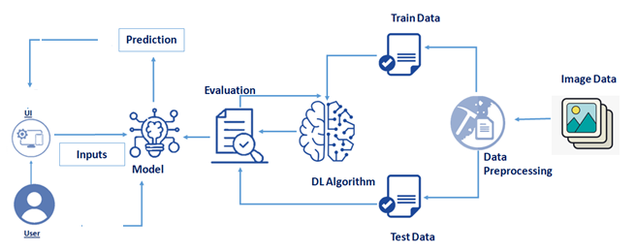

LITERATURE SURVEY :

Nutrition is vital to the growth of the human body. Nutritional analysis guarantees that the meal meets the appropriate vitamin and mineral requirements, and the examination of nutrition in food aid in understanding the fat proportion, carbohydrate dilution, proteins, fiber, sugar, and so on. Another thing to keep in mind is not to exceed our daily calorie requirements. If this limit is surpassed, we may become fat.

**Neutrino:** Artificial Intelligence Nutrition App. As the name implies, the app provides nutrition-based analytics and data to its customers and is quickly becoming a prominent platform for offering AI fitness services. It deploys predictive analysis for personalized data compilation using mathematical and natural language processing (NLP) models. Furthermore, it shares nutrition-related data with its partners via SDK and API integration to improve its services and product offerings. It Is an Israel-based firm created in 2011 that allows pregnant women to customise their body’s nutritional requirements. This software collaborated with IBM’s natural language capability to provide 24-hour assistance and dietary recommendations.

**FitnessAI :** The Ultimate Workout at Home Solution This fitness AI software is designed with personalized training regimens for each individual. It began as “gym only software,” but has now improved its system to satisfy “at home fitness” expectations. FitnessAI says that their algorithm has been trained on over 5.9 million exercises, allowing it to “outperform any human fitness teacher.” Furthermore, it analyzed almost 10 million sets, weights, and reps from about 30000 expert gym-goers and weightlifters during a three-year period. In other words, it is an outstanding illustration of machine learning in action for superior exercise planning

**MyFitnessPal** **:** This app creates a daily food diary for you by recognizing the food from photos you shoot. It is supposed to be as simple as that. You take a picture, dial in data such as whether you are eating breakfast or lunch and add a quick text label, and the app estimates the calorie content. It does a pretty good job, although its estimate can be a bit unpredictable. It also needs a network connection, which is something to think about when eating out.

CONCLUSION :

AI adds more value to customized diet and nutrition apps. Be it meal planning or giving dieting instructions, diet planning apps need AI-driven features.

People can get free and effective workout ideas on these applications.These application have planned workout plans,they can help people to workout effectively in very less time.

These application tell users about their intake and the burning of calories.using this model people know about their Health ,how to maintain fitness and how to make healthy life.

REFERENCE :

AI-Powered Nutrition Apps That Help Fitness Enthusiasts With Their Calorie Intake : <https://analyticsindiamag.com/5-ai-powered-nutrition-apps-thathelp-fitness-enthusiasts-with-their-calorie-intake/>

Neutrino- Artificial Intelligence Nutrition App : https://www.nutrinohealth.com/ <https://www.fitnessai.com/>

Healthifyme-AI Nutrition App: <https://www.healthifyme.com/in/>